**Assignment on Regression Algorithm – Insurance Charges Prediction**

**Question :**

**Problem Statement or Requirement:**

A client’s requirement is, he wants to predict the insurance charges based on the several parameters. The Client has provided the dataset of the same.

As a data scientist, you must develop a model which will predict the insurance charges.

1. Identify your problem statement
2. Tell basic info about the dataset (Total number of rows, columns)
3. Mention the pre-processing method if you’re doing any (like converting

string to number – nominal data)

1. Develop a good model with r2_score. You can use any machine learning

algorithm; you can create many models. Finally, you have to come up

with final model.

1. All the research values (r2_score of the models) should be documented.

(You can make tabulation or screenshot of the results.)

1. Mention your final model, justify why u have chosen the same.

**Solution:**

1. **Problem Statement Identification** : Predicting Insurance Charges.

**3 Stages of Problem Identification** :

Stage 1 : ML

Stage 2 : Supervised Learning

Stage 3 : Regression

1. **Dataset Basic Info** : 1338 rows × 6 columns
2. **Pre-Processing Method** : One Hot Encoding
3. **Good model with r2_score** : [Algorithms Insurance Prediction.zip](Algorithms%20Insurance%20Prediction.zip)
4. **Research on r2_score of the models** :

**Research on Best Model Via R Score Value**

**1.MLR**

**Inference** :

|  |
| --- |
| Best Model is created with r score Value = **0.7894790349867009** |

**Proof:**

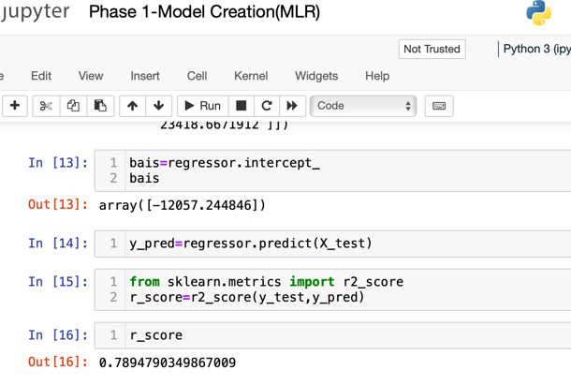

**2.SVMR**

|  |  |  |
| --- | --- | --- |
| **r score Value w/o**  **HTP=** -0.08338238593619329 | | |
| **kernel** | **C Value** | **r score** |
| ***linear*** | 1000 | 0.7649311738597033 |
| 2000 | 0.7440418308108018 |
| **3000** | 0.7414236599249162 |
| ***poly*** | 1000 | 0.856648767594656 |
| 2000 | 0.8605579258597715 |
| 3000 | 0.8598930084494385 |
| ***rbf*** | 1000 | 0.8102064874808204 |
| 2000 | 0.8547766422240716 |
| 3000 | 0.8663393963090398 |
| ***sigmoid*** | 1000 | 0.2874706948697654 |
| 2000 | -0.5939509731283503 |
| 3000 | -2.1244194786689863 |

**Inference** :

|  |
| --- |
| Best model with r score value = **0.8663393963090398** is created for the H.T.P --- **kernel = rbf, c= 3000.** |

**Proof:**

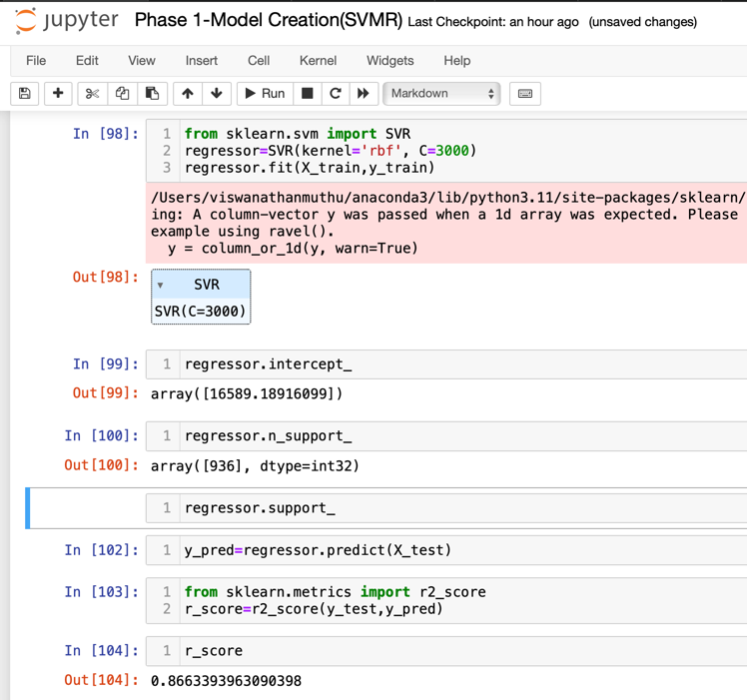

**3.Decision Tree**

|  |  |  |  |  |
| --- | --- | --- | --- | --- |
| **r score Value w/o HTP=** 0.6966581868843034 | | | | |
| **criterion** | **splitter** | **r score (w/o max features)** | **max_**  **features** | **r score**  **( with max_**  **features)** |
| ***squared_error*** | best | 0.686215300008399 | sqrt | 0.6834198870363453 |
| log2 | 0.7025375319783884 |
| random | 0.7066187403980948 | sqrt | 0.6953161555966039 |
| log2 | 0.6893398873680485 |
| ***absolute_error*** | best | 0.6983683936823608 | sqrt | 0.6861931160079187 |
| log2 | 0.6911740381386748 |
| random | 0.6834749673466649 | sqrt | 0.6890368691000321 |
| log2 | 0.6908542771938115 |
| ***friedman_mse*** | best | 0.6865081878698951 | sqrt | 0.7046724095212571 |
| log2 | 0.6814302611125168 |
| random | 0.7003007945640454 | sqrt | 0.68036570083318 |
| log2 | 0.681959664205278 |
| ***poisson*** | best | 0.7137637844731028 | sqrt | 0.6911692507256455 |
| log2 | 0.6899048836268635 |
| random | 0.6894199406241438 | sqrt | 0.6900364781583089 |
| log2 | 0.6971256952095196 |

**Inference** :

|  |
| --- |
| Best model with r score Value = **0.7137637844731028** is created for the HTP --- **criterion = poisson & splitter= best** without  max features |

**Proof:**

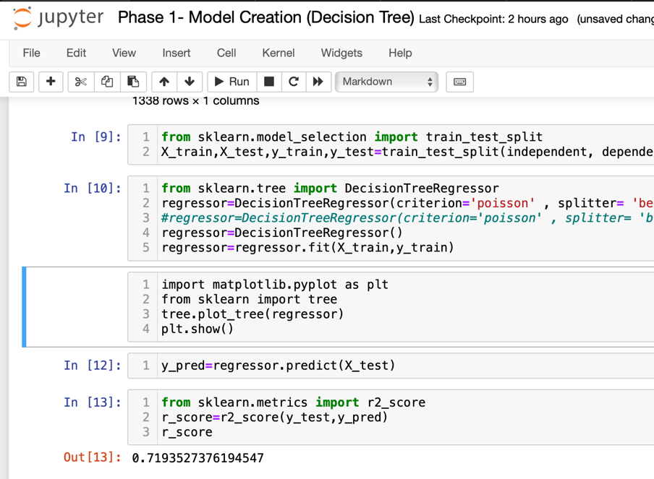

**4.Random Forest**

|  |  |  |  |  |
| --- | --- | --- | --- | --- |
| **criterion** | **n estimators** | **r score**  **(w/o max features)** | **max_**  **features** | **r score**  **(with max features)** |
| ***squared_error*** | 50 | 0.8537074492312178 | sqrt | 0.8699196004695238 |
| log2 |
| 100 | 0.8495860472309916 | sqrt | 0.8712882947395911 |
| log2 |
| ***absolute_error*** | 50 | 0.8533104199010396 | sqrt | 0.8725426987486276 |
| log2 |
| 100 | 0.8522171666048011 | sqrt | 0.8714014632724219 |
| log2 |
| ***friedman_mse*** | 50 | 0.8498058213339406 | sqrt | 0.8698363819890867 |
| log2 |
| 100 | 0.8540807721486975 | sqrt | 0.871314345410434 |
| log2 |
| ***poisson*** | 50 | 0.8491113222296434 | sqrt | 0.8635474039861692 |
| log2 |
| 100 | 0.8526481325996583 | sqrt | 0.8681653187265531 |
| log2 |

**Inference** :

|  |
| --- |
| Best model with r score Value = **0.8725426987486276** is created for the HTP--- **criterion = absolute error & n estimators = 50**  with max features = sqrt & log2 |

**Proof:**

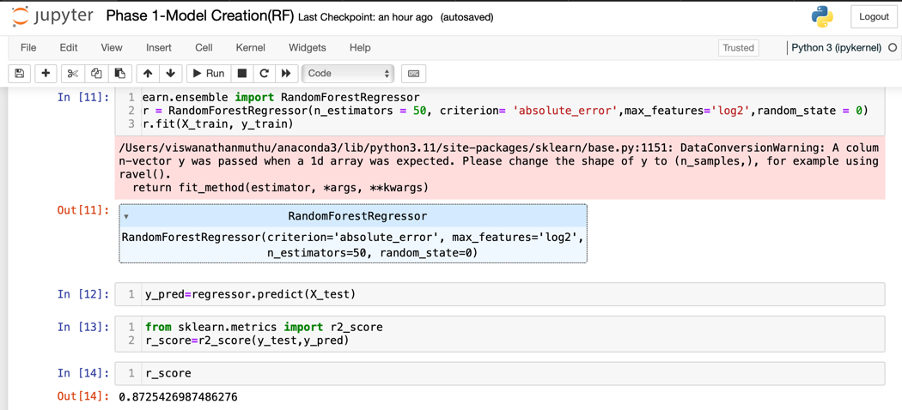

**Summary**

|  |  |  |
| --- | --- | --- |
| **Algorithm** | **HTP** | **Best r score** |
| MLR | - | 0.7894790349867009 |
| SVM | kernel = rbf,  c =3000 | 0.8663393963090398 |
| DT | criterion = poisson & splitter = best | 0.7137637844731028 |
| RF | criterion = absolute error ,  n estimators = 50, max features = sqrt & log2 | 0.8725426987486276 |

**Result Analysis:**

For the given dataset **RF algorithm for HTP criterion = absolute & n estimators = 50**

suits the best with a maximum **r score value = 0.8725426987486276** when compared to the models created by other algorithms.

**Appendix:**

|  |  |
| --- | --- |
| **Abbreviations** | **Expansion** |
| MLR | Multiple Linear Regression |
| SVM | Support Vector Machine |
| DT | Decision Tree |
| RF | Random Forest |
| HTP | Hyper Tuning Parameters |

1. **Final Model :**

For the given dataset **RF algorithm for HTP criterion = absolute & n estimators = 50**

suits the best with a maximum **r score value = 0.8725426987486276** when compared to the models created by other algorithms.